 



**SECOND EDITION**

DHAKA MONDAY MAY 27 , 2024



Regd. No. DA 781

Vol. XXXIV No. 127

Jaishtha 13, 1431 BS

Zilqad 18, 1445 Hijri

24 Pages : Tk 15.00

Nadal bidding to avoid early French Open exit

**P11**

Symbolic and imaginary in Nazrul Islam

**P10**

Children must be protected from abuse and torture

**P8**

670 feared dead in Papua New Guinea landslide

**P7**

**Sundarbans cushions blow**

Remal makes landfall near Khepupara

STAFF CORRESPONDENT

Cyclone Remal battered the coastal region at wind speeds that might have reached 130kmph, and lost much of its strength while sweeping over the Sundarbans, Met officials said.

“As predicted, the centre of the severe cyclone fell between Khepupara in Patuakhali and Sagar Island in West Bengal,” said Abul Kalam Mallik, a meteorologist at Bangladesh Meteorological Department.

He said Bangladesh was on the east of the cyclone’s eye which means Bangladesh took the main blow because the east side of a cyclone always causes more damage than the west side in the sub continent.

“The Sundarbans always acts as a natural shield,” he added.

More than eight lakh people were evacuated to safer areas in 16 coastal districts ahead of the year’s first cyclone.

It brought heavy rains and tidal surges as high as 12 feet yesterday evening.

According to officials, by midnight, wind speed at the coast may have reached 130kmph.

The authorities were yet to assess the extent of damage caused by the cyclone.

A 24-year-old man drowned after he was swept away by the strong current in his flooded village in Kalapara, Patuakhali, while a 65-year- old died after falling from a bicycle while going to a shelter amid strong winds in Satkhira.

People living in some affected areas were left without electricity since Saturday night. Mohibur Rahman, state minister for disaster management, last night said eight lakh people were



Two died in Patuakhali and Satkhira

Eight to 12 feet high storm surge

Highest wind speed 130kmph

Eight lakh people evacuated

evacuated to 9,000 shelters. “There is adequate dry food,

biscuits, safe water and medical supplies there,” he said.

The met office issued the “great danger signal no-10” for Barishal region and its shoals, “great danger signal no-9” for the southeastern coastlines.

The Met department said Remal made landfall between 6:00pm and

midnight.

BENAZIR’S WEALTH

Court orders confiscation of more assets

COURT CORRESPONDENT

A Dhaka court yesterday ordered the authorities concerned to confiscate assets under 119 more deeds of former inspector general of police Benazir Ahmed and his family members in connection with alleged corruption.

T h e

court also d i r e c t e d them to confiscate eight wholly

owned and 15 partially owned properties of Benazir, his wife Jissan Mirza, and three daughters. Judge Mohammed Ash- Shams Joglul Hossain of Metropolitan Senior Special Judge’s Court of

SEE PAGE 2 COL 2

MP AZIM’S MURDER

Aktaruzzaman coordinated murder from Gulshan flat

Say investigators

MOHAMMAD JAMIL KHAN, RASHIDUL HASAN, *and* PALLAB BHATTACHARYA

While killing Jhenaidah-4 MP Anwarul Azim Anar at a Kolkata flat, the

AHSAN HABIB

**Stocks shed 1,000 points in 3 months**

Investors shun the market as economic outlook darkens

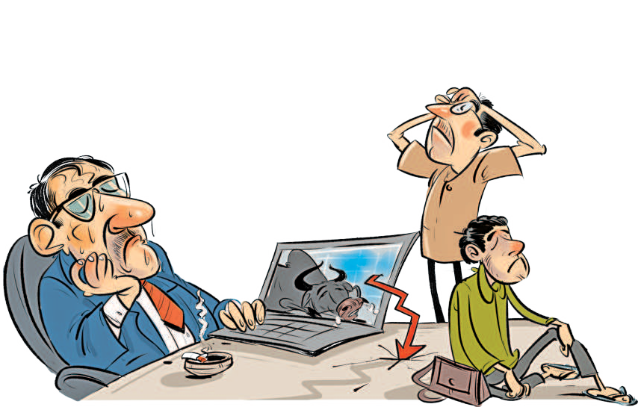

The key Dhaka index declined **16.7**% in the past 52 weeks, while the MSCI AC Asia Pacific Index gained **12.3**%

Analysts blame the market rout on the gloomy economic outlook and wrong policy steps

The value of stocks dropped by Tk **114,845** crore over the last three months

DSE’s daily turnover dropped below Tk **320** crore on Sunday, compared to Tk **1,800** crore in February

**6,259**

**6,215**

**6,075**

**5,898**

**5,901**

**5,615**

**5,860**

**5,778**

**5,653**

**5,615**

**5,692**

**5,696**

**5,431**

**5,250**

raised the interest rate against deposits, Siddiqi clarified.

**“The index is falling**

**mainly due to deterioration of various economic indicators.**

**Investors are in panic, so they keep selling**

**shares.”**

Faruq Ahmad Siddiqi Ex-chairman of Bangladesh Securities and Exchange

Commission

Feb 25

Mar 3

Mar 10

Mar 18

Mar 24

Mar 31

Apr 8

Apr 15

Apr 15

Apr 21

Apr 28

May 5

May 12

May 19

May 26

According to the Indian Met office, wind speeds may reach up to 120kmph, with gusts up to 135 kmph while the storm hits West Bengal’s Sagar Island and Bangladesh’s Khepupara area.

Meteorologists warned that the storm could uproot trees and cause major damage to thatched houses and disrupt power and communication systems.

Authorities closed Bangladesh’s three seaports and airports in coastal districts.

The disaster management ministry said it mobilised tens of thousands of volunteers to quicken the evacuation efforts.

Dhaka and its adjacent districts also experienced gusty wind and rain yesterday afternoon.

assailants were on the phone with mastermind Aktaruzzaman, known in his hometown Jhenaidah as Shaheen Mia, several investigators suspect.

H e

was at his rented flat in Gulshan, Dhaka, at the time

The key index of the Dhaka Stock

Exchange plunged by 1,000 points in a span of three months as investors keep selling their holdings, fearing further deterioration of economic indicators.

The DSEX, the benchmark index of the DSE, has fallen by 1,022 points, or 16 percent, to 5,250 since February 27.

During the period, market capitalisation or share value of the listed companies dropped by Tk 114,845 crore or 15 percent.

Moreover, investors are now worried

over some possible measures, including reimposition of capital gains tax, in the next budget.

Foreign investment is also declining as the local currency massively lost its value against the dollar.

Besides, the central bank allowed foreign deposits through offshore banking. A foreign investor can now get interest rate of more than 8 percent without having to worry about currency

Almost all the coastal districts saw rain and strong winds since

and made

video calls

**Azim**

The index has been falling sharply

since February when Bangladesh

devaluation.

They can enjoy tax-free profit of up to

early yesterday. It started raining heavily in the evening, reported our

correspondents from different districts.

Onrush of water breached embankments along the rivers Shibsa, Kapatakkhya and Koyra at many places in Khulna.

Nine villages in Koyra, Paikgachha and Dacope upazilas were partially submerged.

In Chattogram division, several thousand people of Nijhum Dwip in Noakhali’s Hatiya upazila, were in fear as there is no embankment around the island.

The man who died in the Kawarchar area of Kalapara was named Shariful Islam. Locals said he was trying to save his mother-in-law and sister next to their home when he was swept away by the water.

The man who died in Satkhira’s Shyamnagar was Shawkat Morol, reports our Satkhira correspondent.

with the assailants, they added.

Officers earlier said Azim and Aktaruzzaman used to run a gold smuggling racket until they fell out over money last year and Azim kept a stash worth over Tk 100 crore to himself.

After making the arrangement in Kolkata, Aktaruzzaman returned

SEE PAGE 2 COL 5

Securities and Exchange Commission (BSEC) withdrew the floor price that was launched in mid-2022.

The system was introduced to stem the market fall amid economic turmoil that resulted from the Ukraine-Russia war. The unusual mechanism failed to prevent the index from falling.

Talking to The Daily Star, Faruq Ahmad Siddiqi, a former chairman of the BSEC, said the index is falling mainly due to deterioration of various economic indicators. Investors are in panic, so they keep selling shares.

When economic indicators don’t do well, it impacts the performance of the listed companies, leading to a drop in their share prices.

On the other hand, the interest rate for treasury bills and bonds rose to more than 12 percent. It is only logical that institutional investors will transfer their funds to the bond market, he pointed out.

As the government missed the revenue collection target, it had to borrow heavily from banks, creating a liquidity pressure in the banking sector. And it ultimately

8.40 percent on fixed deposits in the US dollar or the euro for terms ranging from three months to five years, according to the Offshore Banking Act 2024 that took effect in March.

Siddiqi said, “If they can get such a high interest by investing in safe instruments, why would they take the risk of investing in the stock market?”

Foreign investors started selling shares on a large scale after the floor price was withdrawn in January this year.

Shekh Mohammad Rashedul Hasan,

SEE PAGE 2 COL 2

BUDGET FOR FY25

STORY ON B1

**NBR may miss tax collection target again**

The National Board of Revenue (NBR) posted about 16 percent

year-on-year growth in tax collections in the first 10 months of the current fiscal year. Still, it might be

tougher for it to attain the government’s goal of raising Tk 410,000 crore by the end of the year.

Two research agencies also said the target, which many have described as ambitious at the beginning of the year, would once again remain unachieved.

The revenue administration raised Tk 289,376 crore in July-April of FY2023- 24, which represented 70 percent of the revised target for the year, shows provisional data of the NBR.

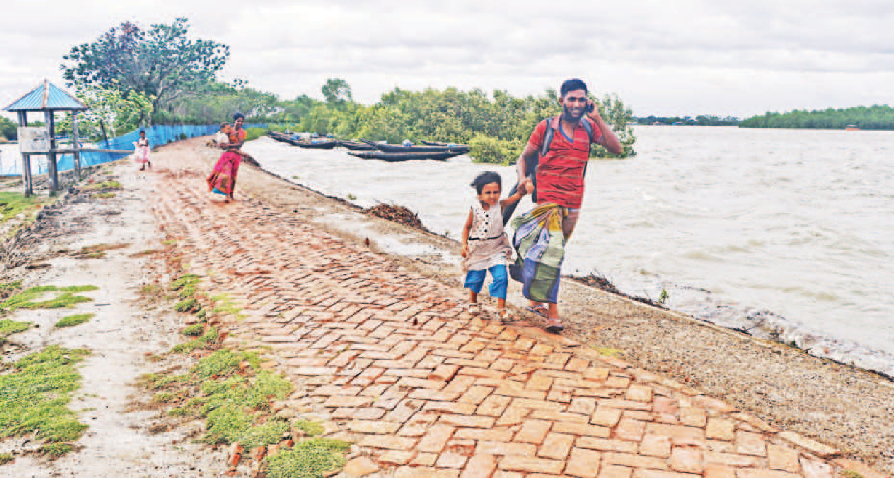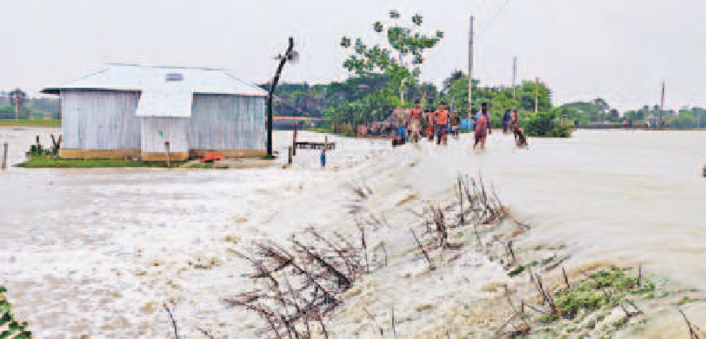

**Locals of Gabbunia village in Khulna’s Koyra upazila were going home to collect necessary items before heading to shelters as Cyclone Remal was hurtling towards the southwestern coast yesterday. People in the coastal areas were asked to take precautions ahead of the storm’s arrival. *Inset*, just before Remal’s landfall, water rushed onto Char Montaz of Patuakhali’s Rangabali upazila.**

PHOTOS: **HABIBUR** **RAHMAN** **AND** **SOHRAB** **HOSSAIN**

**Scope likely for legalising black money**

Govt also mulling ways to bring laundered money home

REJAUL KARIM BYRON

The government is thinking about allowing again undisclosed money to be legalised and laundered money to be brought back home through formal channels in the next budget.

A finance ministry official said the National Board of Revenue and Bangladesh Bank are trying to find out ways this could be done.

The official said they were considering to impose a 15 percent tax on legalising black money.

Similar steps had been taken in the past, but the result was not as expected, the official added.

Economists and government officials suspect that a huge amount of money was laundered abroad before the January 7 parliamentary polls.

Besides, a significant amount of foreign currency was also sent abroad in the name of export-import, which is reflected in more than $10 billion deficit in the financial account of balance of payment.

The official said the government was weighing options so that the money could be brought back home for boosting the foreign currency reserves.

Asked if the government was going to allow legalising

SEE PAGE 2 COL 2